CLIENT WELCOME PACKAGE - WORKSHEET 2

TAKING STOCK IN YOU (pls contemplate, complete …and enjoy! Sharing back will also very much empower our work together.)
1. Life Balance Wellness Wheel (5 minutes)
2. A Successful Life Is... (10 minutes)
3. My Belief Biases & Roadblocks (20 minutes) 4. Current Dreams & My Ideal Day (15 minutes)
In this is section you are invited to engage in several self-reflective exercises. None of these exercises require more than a few minutes of your time unless you decide to give it more.
Let yourself become curiously open to looking into your life, including: your past conditioning and beliefs; your future hopes and dreams; and your current situations and circumstances.
You do not have to share any of this with me, but it will make our process so much more targeted and it will empower my capacity as your advisor if you choose to share.
I look forward to showing you just how important this self-knowledge will be to the financial road map we will be creating for you....
PERSONAL & CONFIDENTIAL
All information you share with us, remains personal, private, and confidential.

II-1 Life Balance Wellness Wheel Exercise (5 minutes)
This is simple and often life clarifying: First, draw a circle with pie slices for each key area of your life (or simply use the wheel depicted below). Then darken the appropriate circle within each slice ) to reflect your own (self-assessed) opinion of the your current degree of wellness in that area (using a scale from 1-10 -- 1 being very poor; 10 being excellent). Once you’ve completed each slice in your pie, connect the dots to get a quick visual on where you are most “in” and most “out” of balance in your life at present (see sample in small chart to the right).

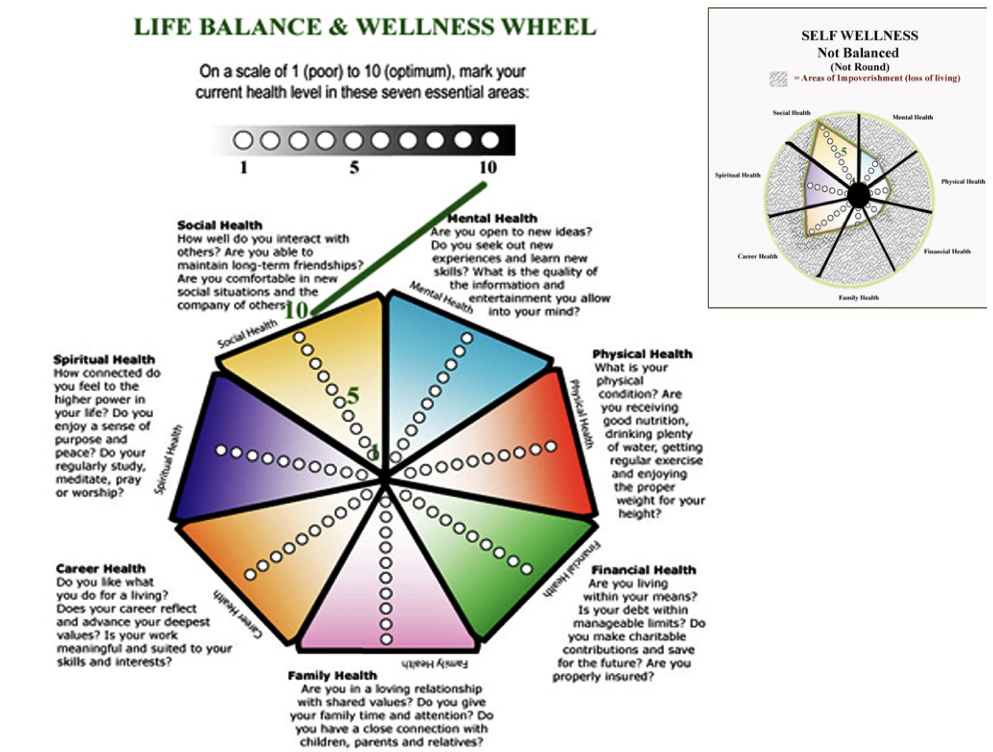

II-2 A Successful Life Is... (1 Paragraph/ 9 minutes)
Please see what comes to you when I ask you these questions below, and then simply write your most thoughtful and truthful reply. I encourage you to go deeply and to allow yourself to wonder, question and to be surprised at what comes to you.
(NOTE: You can answer each question separately, or just choose to answer any one that best captures your sense of a “life credo” – i.e., what you live by)
1. What, for you is a life well-lived?
2. When it is all said and done, how would you like to be remembered?

3. A successful life, to me is:....

I-2a (Bonus Question) If you had to choose only one word to describe what you most value in life, what would it be?

II-3 My Belief Biases & Roadblocks (1 Paragraph/ 20 minutes or so)
One of the key areas virtually ignored in all standard financial planning and investment strategies today, is an awareness of the inherent (and subconscious) biases we each have around our money, our sense of worthiness, and our capacity for success.
Everyone has early childhood conditioning and life experiences that create both conscious and unconscious beliefs around success, money, self-esteem, worthiness etc. These conditioned patterns continue to color and impact our lives our loves and our experiences in ways that most people never realize because they are unaware of the biases and beliefs they inherited from their early life experiences.
When we don’t know what our unconscious biases and beliefs are, we simply act them out. For example, some people inherited the unconscious belief in their family that: “money doesn’t grow on trees”; or “they’re filthy rich”; or “money is the root of all evil”, “money buys happiness” etc.
Our conditioned beliefs about money are especially triggered during times of transition or fear. One financial fear bias for example is to become closed down and paralyzed over financial decisions that need be made. Another person will react to that same fear by going into a kind of blind denial spending spree. (... Imagine what happens in a household where you have these 2 styles operating during the same financial threat or life transition...)
In my many years of professional experience, I have come to deeply respect that one of the most profound functions I can offer as your financial adviser, is to help both of us identify early biases and potential roadblocks to successfully achieving your desired financial goals.
~ ~~
7 GAME – CHANGING QUESTIONS
This is a very important section of the home prep materials. (It’s often difficult to accurately see our own unconscious beliefs... This section should help you to tease them out.) Please answer EACH question as honestly as you can.
1) What attitudes toward money do you recall from your early family life? (What were your parents attitudes toward money; any phrases they may have used; what was the feeling of wealth or lack of in your home growing up)

2) If you were to describe (in ONE sentence) your father when you were young, what is that one sentence? (Think of a movie title tagline)

3) If you were to describe (in ONE sentence) your mother when you were young, what is that one sentence? (Think of a movie title tagline)

4) Think back over your life and note any repeated circumstances or repeated patterns/roadblocks you have experienced. (Simply bullet the repeated patterns or name the “roadblocks”

5) What is the one “self-doubting” thought or fear you have about yourself? (Please be honest. We ALL have them! For example: “being unworthy”, “not good enough”, “too unsure”, “being found out as a fraud”, “becoming a bag lady”). Identify your secret self-doubt:

6) If you suddenly lost every material possession you have, you would:

7) If you suddenly were given $10 million cash, you would:

II-4 Current Dreams & My Ideal Day (15 minutes)
This section is more enjoyable than the last – Together, they are equally important to building your
successful financial road map.
Another of the key distinction in our financial investment management services over the common stockbroker or banking relationship, is this:
We create a “living breathing” FINANCIAL NAVIGATION for achieving your goals and dreams. What do we mean by a “living breathing: financial road-map? Think of your financial goals like a GPS system for your car when taking a trip. Most GPS systems will find the direct route. Other more complex GPS systems will show you the shortest route along with alternatives – some that take longer but offer more interest and enjoyment and points of interest along the way; some can show you up-to-the-minute detours in real time and based on what is happening as you drive.
Your financial GPS with Clements Investment Management, Inc., is like having a live-streaming GPS at hand: We create a financial road map that identifies the direct route, as well as alternative routes suited to the things you also want to do along the way...AND we “go live” which means that as new circumstances or ideas or purchases of interest crop up along the way, we can “recalculate” and identify and advise you on several updated routes and maps for achieving your destination while enjoying the stop overs along the way.
So, in this section: please have some “dreamy fun” We are going to get down to the “hard facts and figures and make the map laying decisions next. But first is really truly is important to have some idea of the values you place on your current lifestyle and some things you really want and hope to incorporate into your route or to stop and experience and enjoy now in the next 5 years and along the way.

a) Current Dreams
Within the Next 3 Years: What significant purchases, vacations, or opportunities do you sincerely hope to afford/experience?

Please list anything you sincerely would hope to be able to afford to do within the next 3 years and list the approximate financial cost (e.g., spend a month at a beach house; become a small airplane pilot; a desired cosmetic surgery; buy a new car, etc)

WISH ITEM: APPROX. $

b) An Ideal Day (1 Page/15 minutes)
Please allow yourself to day dream and write (in detail) one full picture of what you would consider AN IDEAL DAY: starting with getting up in the morning and going to bed at night (what time, what you do, what you do next, what your day looks and feels like etc.) Be as visually descriptive and free as you can.

