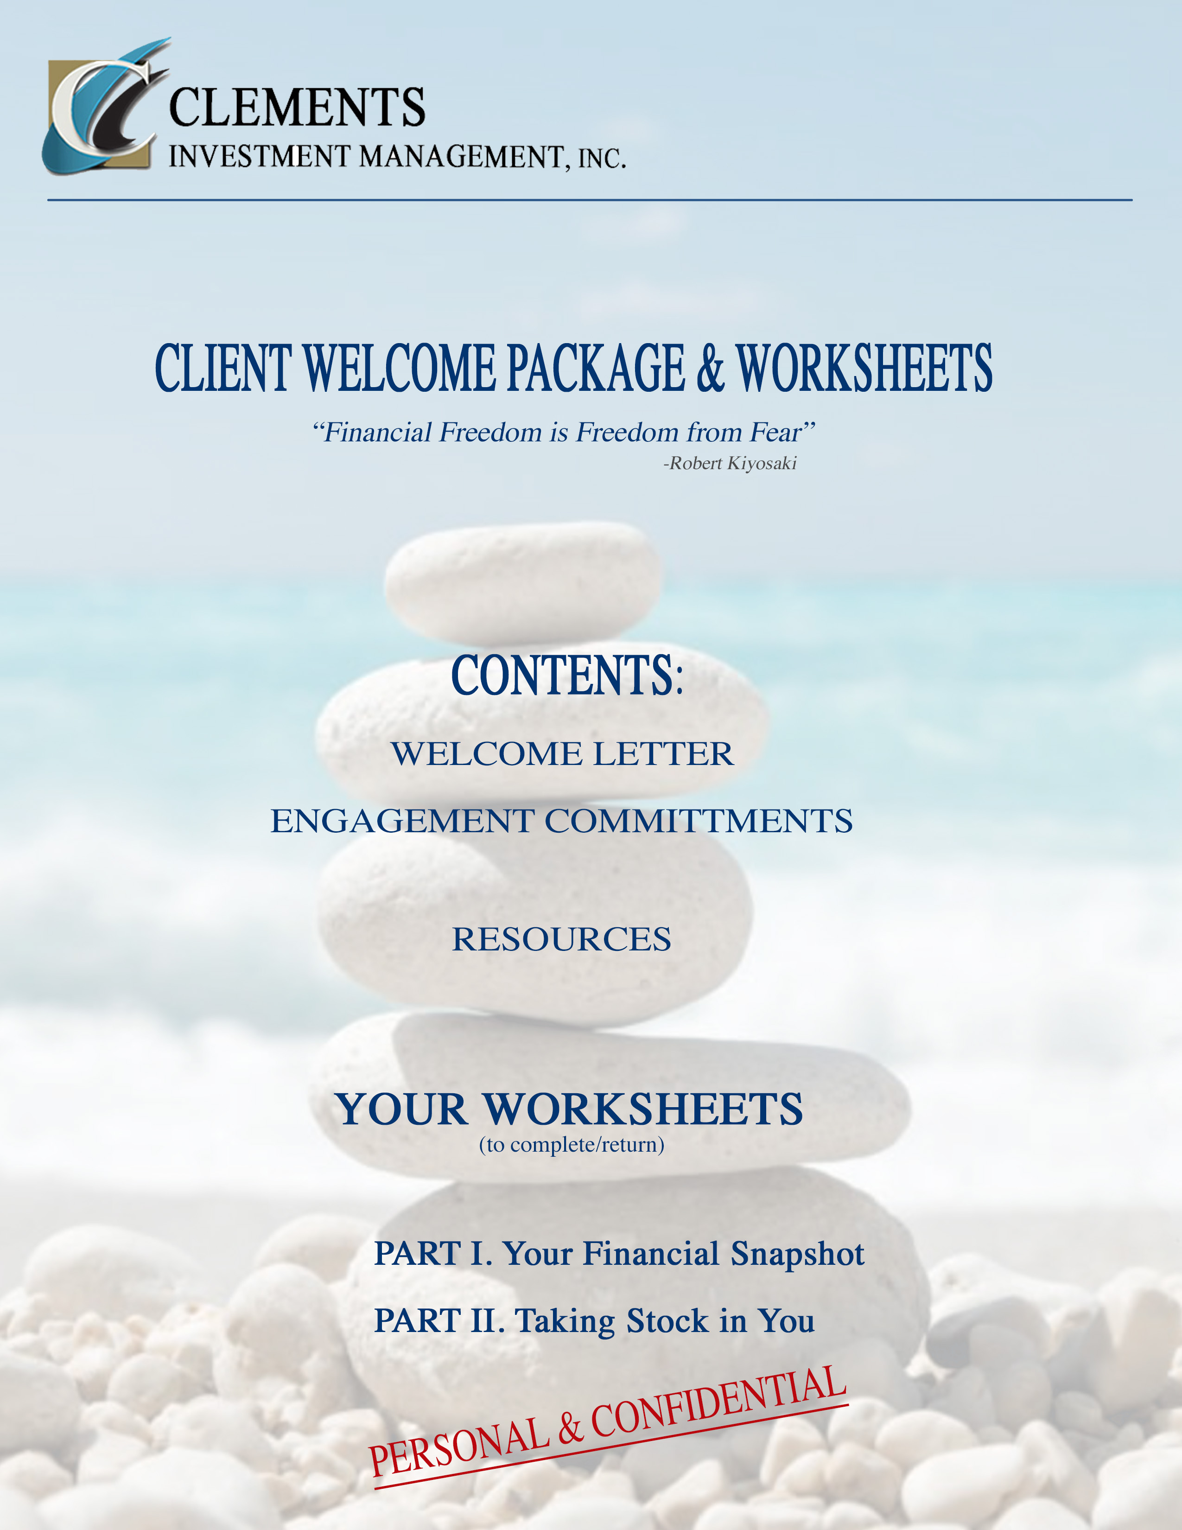

WELCOME LETTER

It is my pleasure to welcome you to our uniquely integrated financial investment planning and ongoing financial consulting services.

I am confident that you will quickly realize what a difference our approach will make in your life.

Having dedicated over 3 decades of my professional life as a financial investment adviser, I have to thank my client/friends who have, themselves, firmly expressed and shown me over these many years, that the optimal way for me to personally serve in my professional capacity as financial adviser, is by knowing what makes you tick; what brings you meaning; and what, for you, is a life well lived.

Most of you I imagine are accustomed to the standard investment services offered by your bank or stockbroker. You probably think of a financial adviser as someone who looks over your assets, asks you a few questions about your long-range goals and your risk tolerance, and shows you 2 or 3 investment packages that he/she advises, and from which you the select the package that seems best to you. That’s usually about it. Then your money is placed into that portfolio, and you receive quarterly reports, and perhaps an annual or biannual review. About it, right?

That is not “about it” when you and I mutually decide to enter into a financial consulting partnership together at Clements Investment Management Inc. I’ve come to realize that no financial person nor investment company can optimally manage a financial portfolio in the long run if they have not discussed your highest life values; your long-range desires; your short-range needs and concerns; your immediate play money plans and expenditures; life arising unanticipated issues; and any old patterns or unconscious beliefs that may be keeping you stuck from experiencing your life to its fullest.

In fact, I consider it my obligation to you that we DO talk about your money and your vision; your fears and your dreams; your health and your wealth; the places where you excel in life and the places where you find yourself getting stuck. How on earth can we craft a solid, meaningful and useful financial management tool if we don’t really know who you are, where you stand, and where you are headed?

So yes: Clements Investment Management Inc. is different from the old static model of patriarchal money management. But yes too: I guarantee you that Clements Investment Management Inc. is fully empowered with the same tools, technologies, protections, and price points as other investment firms.

I absolutely know (and am told over and over by my select client base) that our key difference is what makes all the difference! We want to know you. We want to really know who you are as well as what you yearn for and where your roadblocks may lie. With this integral foundation we can then work together to pave the most customized road map possible for successfully placing, managing, reviewing, and enjoying your wealth-building progress at each milestone and vista-point along your route.
So, if this is not something you are seeking, please accept and take advantage of these free exercises in this welcome package, and no need to go further.
But, if you are like me, and you are in this life to exercise your mastery of the journey while growing your capacity for enjoyment of life along the way… then let’s get started.

I look forward to co-creating your road map, and to our growing connection in all areas of this financial advisory partnership and life journey.

Mattawe P. Clements, RIA
Clements Investment Management, Inc.

P.S. Please start working on the attached HOME PREP WORKSHEETS in order for us to begin. It is my hope and expectation that you will find this a very meaningful and fruitful journey taken

ENCLOSURES:

ENGAGEMENT COMMITMENTS (Ours and Yours)
RESOURCES

HOME PREP WORKSHEETS (for you to please complete for starter meetings)

I. Financial Snapshot (pls complete)
  - Personal Information Sheet
  - Current I/E Snapshot
  - Other Financial Commitments and Considerations
  - Notes

II. Taking Stock in You (pls contemplate and complete – and enjoy)
  - Life Balance Wellness Wheel
  - A Successful Life Is…
  - Belief Biases & Roadblocks
  - Current Dreams & Ideal Day

ENGAGEMENT COMMITMENTS

Here are the engagement expectations and commitments you can count on in your tenure with Clements Investment Management Inc., as well as those we will expect and hold you to in this financial trust and strategic partnership.

CLEMENTS INVESTMENT MANAGEMENT, INC. TERMS AND PROMISE:

- Complete Confidentiality
- Clear Communication and Transparency at all Times
- Competitive Comprehensive Offerings & Pricing
- Comprehensive, Integrated and Personalized “Financial GPS System”
- Code of Ethics: RIA requires Highest Fiduciary Standards as with your CPA / Attorney
- Compassionate & Informed Counsel and Connection

CLIENT (YOUR) COMITTMENT and AGREEMENT:

- Complete and Accurate Information
- Open and Honest Communication
- Agreeable to Annual (at Minimum) Review
- Forthright with Questions and Changing Circumstances
- Committed to an Engaged Personalized Working Partnership
- Willing to Expand and Discover New Personal Growth Horizons

RESOURCES

Website: MPCLEMENTS.COM

A Couple Articles:

Market Correction and Retirement Planning

Midlife Crossroads & Financial Choices
A Few Book Recommendations

- THE MONEY CODE, by Joe Duran
- POOR CHARLIES ALMANACK: The Essential Wit and Wisdom of Charles T Munger Edited By Peter D Kaufman
- WHAT YOU SAY WHEN YOU TALK TO YOURSELF by Ahad Helmstetter Ph.D.

HOME PREP EXERCISES:
Enclosed you will find a package of self-reflective exercises and worksheets.
I invite you to empower your financial future by created personal time to reflect upon and complete these set of questions.
You may elect to use these worksheets merely for your own self-reflection initial financial planning. However, if you are willing to utilize and share your reflections and worksheets with me more directly, you will empower our team work and capacity for creating a much more potent, responsive and effective financial road map on your behalf. *
You can engage in these exercises by doing one or two when you have a few minutes – or you can do them all together at one time. It is our hope that you become quite intrigued with some of these self-reflective questions, and that you choose to engage them quite fully.
*Please do accept the unique invitation of our customized services by truly engaging and sharing with us what you discover about yourself though this set of exercises. The more fully we know you, the more powerfully successful will be the road map we create as well as your freedom of life enjoyment along the way.

ATTACHMENT I: FINANCIAL SNAPSHOT (pls complete and share back)
- Personal Information Sheet (2 minutes)
- Current Income/Expense Snapshot (25 minutes)
- Other Financial Commitments and Considerations (15 minutes)
- Notes (4 minutes)
In this section, you will be answering a few “broad brush stroke” questions about your financial picture; anticipated future financial considerations; and offer some basic background information about yourself to help us start to build an informed foundation.
In Part II, you will be invited to delve more deeply into beliefs, attitudes, dreams, and roadblocks that may help or hinder your life style and financial goals.
The two parts, together, form a very unique and powerful basis for the integrated financial GPS system we will be creating together and on your behalf.
We will go into far more depth than these initial questions when we begin the actual financial planning documents. For now, these questions will give us a working snapshot informing us of key areas in which to next focus.
PERSONAL & CONFIDENTIAL
All information you share with us, remains personal, private, and confidential.

I-1 Personal Information Sheet (2 minutes) Please provide all of the following personal information
Full Name: ___________________________________________________ Address: ___________________________________________________ ___________________________________________________
Work Phone: _____________________ Home Phone: _____________________ Cell Phone: _____________________
Primary Email Address: __________________________
Date of Birth: _____________________
Marital Status (M/S/D/W) Spouse’s Name (if applicable): __________________________
Number Currently Living in Your Household: __________
# of Children: _____ & Ages: _________________________________________
Your Trust Attorney Company Name: _________________________________________ Your CPA Company Name: _________________________________________
Where Do You Bank? _________________________________________
Your Brokerage Firm: _________________________________________
Date of Financial Plan: ______________ Date of Last Review: _____________

I-2 Current Expense/Income Snapshot (E/I Worksheet 25 minutes)
Please list your current expenses and income here. This information will enable me to know where to delve more deeply as needed in our future work together. You only need rough in the basics here (being accurate as you can). We will fine tune and be much more specific in our future work together. This is just to help give us a broad picture to start with.
1) Annual Household Income: $______________________________
2) Total Average Monthly Expenses: $______________________________
3) Current “Net Worth”: $______________________________
4) Amount of Current Liquid Assets (i.e., Total in Bank Accounts): $________________________ 5) Total Amount of all Debt (Mortgage, Credit Card, Other Combined) $_____________________
6) List What You Consider to be Your “True Currencies”
7) Using a Scale from 1-10 (1 Being Not At All and 10 being Totally) how comfortable are you right now with your wealth?
1....2....3....4....5...6...7...8...9...10
8) What areas of wealth building and money management most concern you?
9) What areas of wealth building and money management most interest you?

I-3 Other Financial Commitments and Considerations (15 minutes)
Please list any upcoming or financial commitments or considerations that are anticipated or expected within the next 3-5 years (such as college costs; elder care; inheritance; sale of business; sale of other investments etc.) This is simply a “big picture snapshot” for now. We will make a more detailed document and formulation at a meeting together in the near future.

LIST ANTICIPATED EXPENSES: APPROX $

LIST ANTICIPATED INCOME APPROX $

I-4 Notes
Please use this space for any additional thoughts, questions, or considerations.

ATTACHMENT II: TAKING STOCK IN YOU (pls contemplate, complete …and enjoy! Sharing back will also very much empower our work together.)
1. Life Balance Wellness Wheel (5 minutes)
2. A Successful Life Is... (10 minutes)
3. My Belief Biases & Roadblocks (20 minutes) 4. Current Dreams & My Ideal Day (15 minutes)
In this is section you are invited to engage in several self-reflective exercises. None of these exercises require more than a few minutes of your time unless you decide to give it more.
Let yourself become curiously open to looking into your life, including: your past conditioning and beliefs; your future hopes and dreams; and your current situations and circumstances.
You do not have to share any of this with me, but it will make our process so much more targeted and it will empower my capacity as your advisor if you choose to share.
I look forward to showing you just how important this self-knowledge will be to the financial road map we will be creating for you....
PERSONAL & CONFIDENTIAL
All information you share with us, remains personal, private, and confidential.

II-1 Life Balance Wellness Wheel Exercise (5 minutes)
This is simple and often life clarifying: First, draw a circle with pie slices for each key area of your life (or simply use the wheel depicted below). Then darken the appropriate circle within each slice ) to reflect your own (self-assessed) opinion of the your current degree of wellness in that area (using a scale from 1-10 -- 1 being very poor; 10 being excellent). Once you’ve completed each slice in your pie, connect the dots to get a quick visual on where you are most “in” and most “out” of balance in your life at present (see sample in small chart to the right).

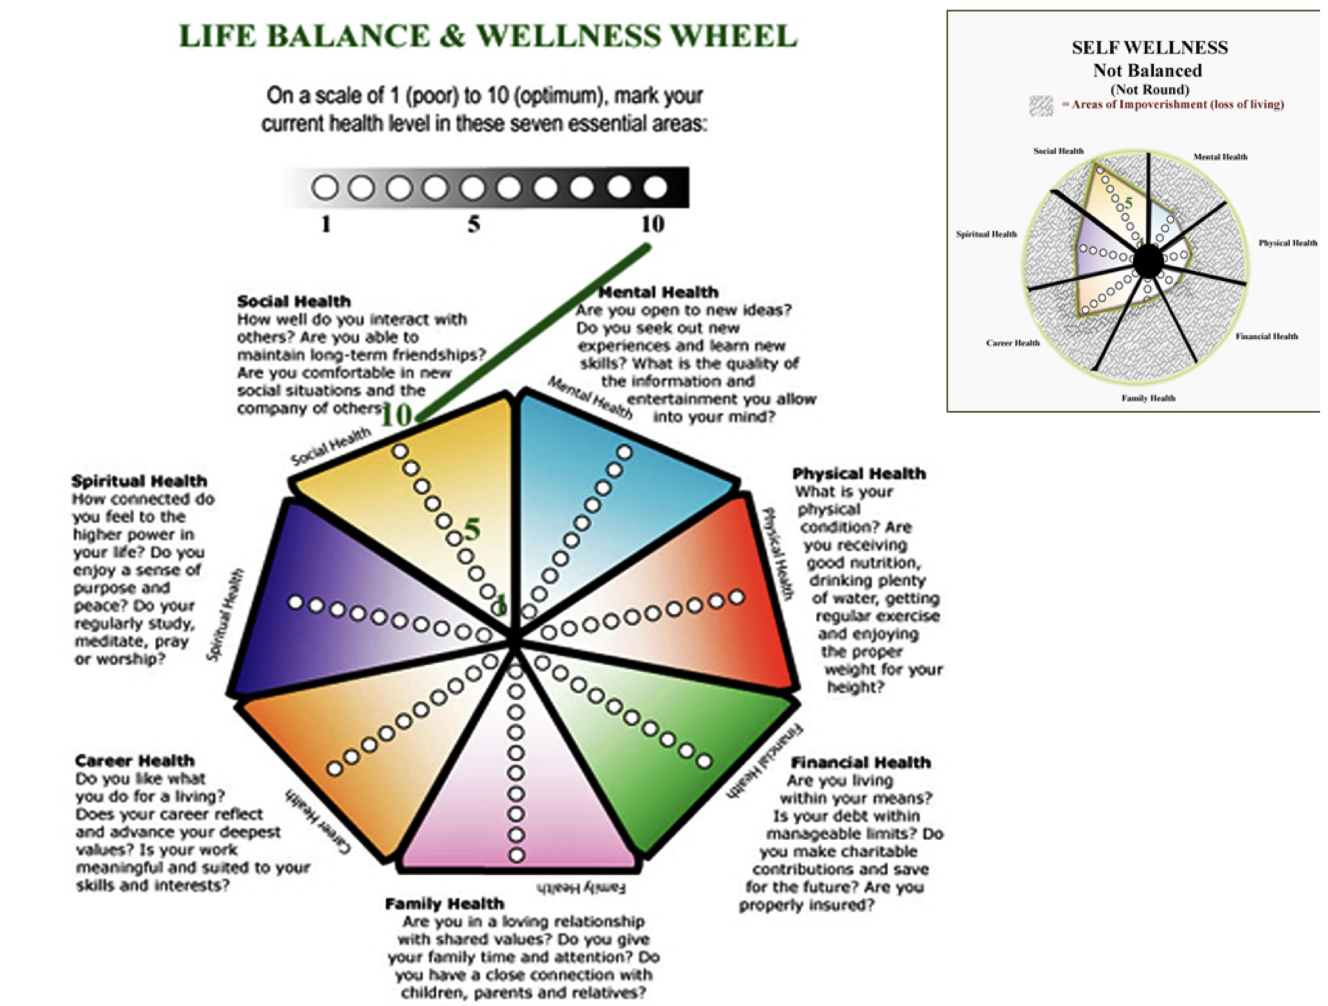

II-2 A Successful Life Is... (1 Paragraph/ 9 minutes)
Please see what comes to you when I ask you these questions below, and then simply write your most thoughtful and truthful reply. I encourage you to go deeply and to allow yourself to wonder, question and to be surprised at what comes to you.
(NOTE: You can answer each question separately, or just choose to answer any one that best captures your sense of a “life credo” – i.e., what you live by)
1. What, for you is a life well-lived?
2. When it is all said and done, how would you like to be remembered?

3. A successful life, to me is:....

I-2a (Bonus Question) If you had to choose only one word to describe what you most value in life, what would it be?

II-3 My Belief Biases & Roadblocks (1 Paragraph/ 20 minutes or so)
One of the key areas virtually ignored in all standard financial planning and investment strategies today, is an awareness of the inherent (and subconscious) biases we each have around our money, our sense of worthiness, and our capacity for success.
Everyone has early childhood conditioning and life experiences that create both conscious and unconscious beliefs around success, money, self-esteem, worthiness etc. These conditioned patterns continue to color and impact our lives our loves and our experiences in ways that most people never realize because they are unaware of the biases and beliefs they inherited from their early life experiences.
When we don’t know what our unconscious biases and beliefs are, we simply act them out. For example, some people inherited the unconscious belief in their family that: “money doesn’t grow on trees”; or “they’re filthy rich”; or “money is the root of all evil”, “money buys happiness” etc.
Our conditioned beliefs about money are especially triggered during times of transition or fear. One financial fear bias for example is to become closed down and paralyzed over financial decisions that need be made. Another person will react to that same fear by going into a kind of blind denial spending spree. (... Imagine what happens in a household where you have these 2 styles operating during the same financial threat or life transition...)
In my many years of professional experience, I have come to deeply respect that one of the most profound functions I can offer as your financial adviser, is to help both of us identify early biases and potential roadblocks to successfully achieving your desired financial goals.
7 GAME – CHANGING QUESTIONS
This is a very important section of the home prep materials. (It’s often difficult to accurately see our own unconscious beliefs... This section should help you to tease them out.) Please answer EACH question as honestly as you can.
- What attitudes toward money do you recall from your early family life? (What were your parents attitudes toward money; any phrases they may have used; what was the feeling of wealth or lack of in your home growing up)

2) If you were to describe (in ONE sentence) your father when you were young, what is that one sentence? (Think of a movie title tagline)

3) If you were to describe (in ONE sentence) your mother when you were young, what is that one sentence? (Think of a movie title tagline)

4) Think back over your life and note any repeated circumstances or repeated patterns/roadblocks you have experienced. (Simply bullet the repeated patterns or name the “roadblocks”

5) What is the one “self-doubting” thought or fear you have about yourself? (Please be honest. We ALL have them! For example: “being unworthy”, “not good enough”, “too unsure”, “being found out as a fraud”, “becoming a bag lady”). Identify your secret self-doubt:

6) If you suddenly lost every material possession you have, you would:

7) If you suddenly were given $10 million cash, you would:

II-4 Current Dreams & My Ideal Day (15 minutes)
This section is more enjoyable than the last – Together, they are equally important to building your
successful financial road map.
Another of the key distinction in our financial investment management services over the common stockbroker or banking relationship, is this:
We create a “living breathing” FINANCIAL NAVIGATION for achieving your goals and dreams. What do we mean by a “living breathing: financial road-map? Think of your financial goals like a GPS system for your car when taking a trip. Most GPS systems will find the direct route. Other more complex GPS systems will show you the shortest route along with alternatives – some that take longer but offer more interest and enjoyment and points of interest along the way; some can show you up-to-the-minute detours in real time and based on what is happening as you drive.
Your financial GPS with Clements Investment Management, Inc., is like having a live-streaming GPS at hand: We create a financial road map that identifies the direct route, as well as alternative routes suited to the things you also want to do along the way...AND we “go live” which means that as new circumstances or ideas or purchases of interest crop up along the way, we can “recalculate” and identify and advise you on several updated routes and maps for achieving your destination while enjoying the stop overs along the way.
So, in this section: please have some “dreamy fun” We are going to get down to the “hard facts and figures and make the map laying decisions next. But first is really truly is important to have some idea of the values you place on your current lifestyle and some things you really want and hope to incorporate into your route or to stop and experience and enjoy now in the next 5 years and along the way.

a) Current Dreams
Within the Next 3 Years: What significant purchases, vacations, or opportunities do you sincerely hope to afford/experience?

Please list anything you sincerely would hope to be able to afford to do within the next 3 years and list the approximate financial cost (e.g., spend a month at a beach house; become a small airplane pilot; a desired cosmetic surgery; buy a new car, etc)

WISH ITEM: APPROX. $

b) An Ideal Day (1 Page/15 minutes)
Please allow yourself to day dream and write (in detail) one full picture of what you would consider AN IDEAL DAY: starting with getting up in the morning and going to bed at night (what time, what you do, what you do next, what your day looks and feels like etc.) Be as visually descriptive and free as you can.

